# **Logistic Regression**

## **Plan**

1. Primers & Problem Statement
2. Logistic Regressions
3. Interpretation
4. Performance Evaluation
5. Multicollinearity issues in Linear Models (Lin/Log)

[Lecture notebook](https://github.com/lewagon/data-lecture-starters/blob/main/starters/04-Decision-Science_04-Logistic-Regression.ipynb)

## **1. Primers**

log

2

(

8

)

=

3

log

2

(

1

2

)

=

−

1

ln

(

5

)

=

log

e

(

5

)

=

1.6

e

0

=

2

0

=

1

A probability of 0.9 (a.k.a 90%) can be represented as:

P

(

Event

)

=

0.9

This means that out of 100 occurrences, the event is expected to happen 90 times.

#### **The problem: How can we predict a binary outcome?**

* Win / Loss ?
* Success / Failure
* dim_is_one_star or not?

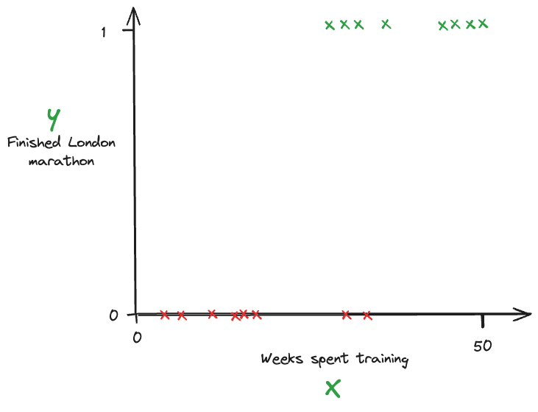

Instead of fitting the best **straight line**

l

i

n

r

e

g

(

x

)

=

β

0

+

β

1

X

...

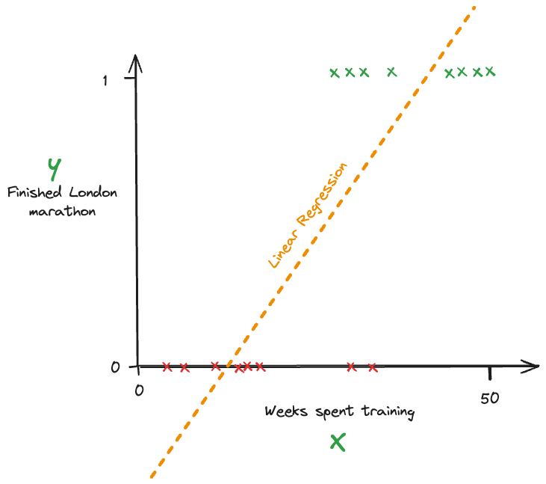

We will try to fit the best **sigmoid function**

^

y

=

s

i

g

m

o

i

d

(

x

)

=

1

1

+

e

−

(

β

0

+

β

1

x

)

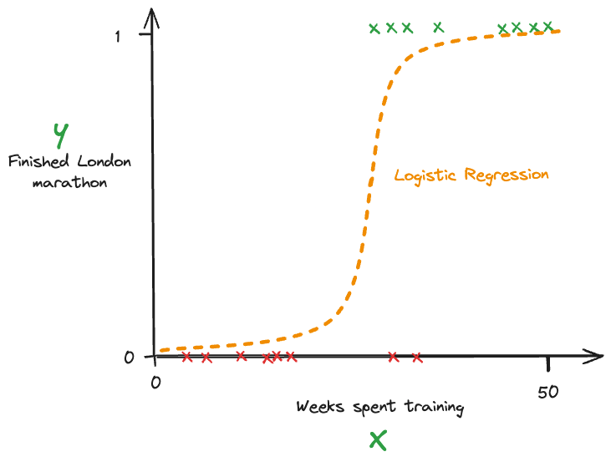

Then, we set a **classification threshold** (usually at 50% by default)  
🔴 observations predicted with

^

y

>

0.5

are classified as 1's  
🔵 observations predicted with

^

y

<

0.5

are classified as 0's

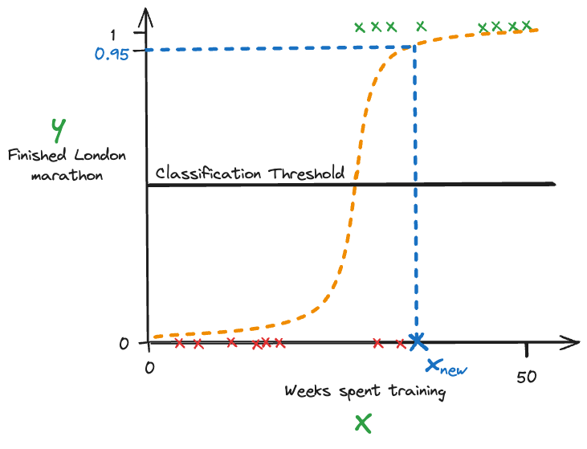

## **2. Logistic Regressions**

### **The Barcelona Women's Football Team is going on tour**



* Every game is a win-lose scenario (they play penalties to avoid draws!)
* We are given the opportunity to bet on the team **before** the tour happens

#### **Probability, Odds and Log-Odds 💪**

Imagine we go to some gambling website...

They show us what they think the probability of Barca winning will be:

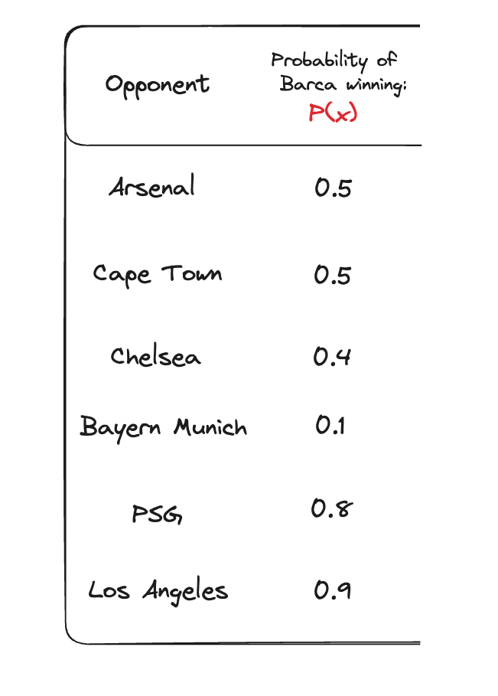

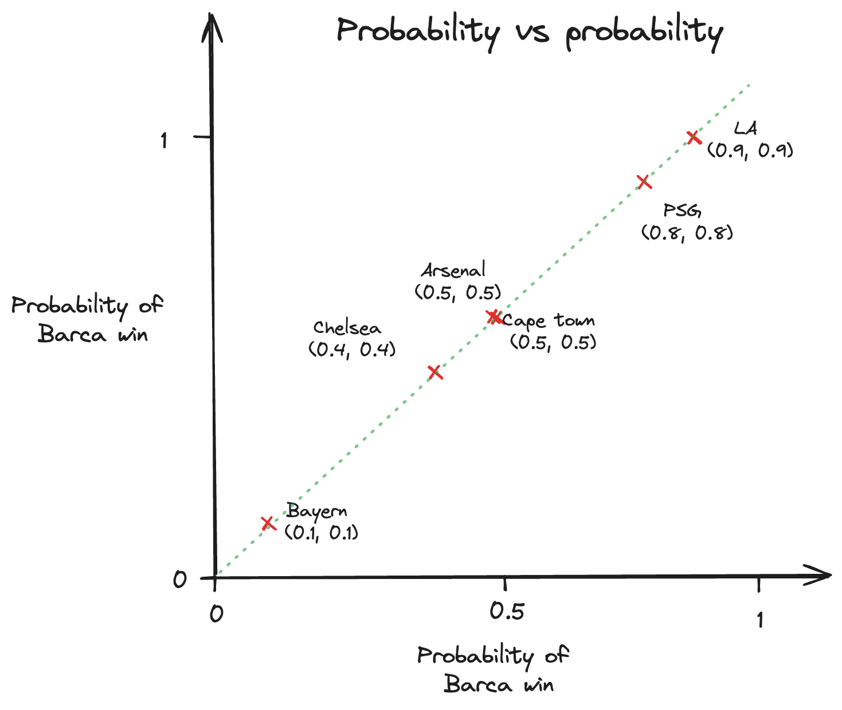

They also show us the odds!

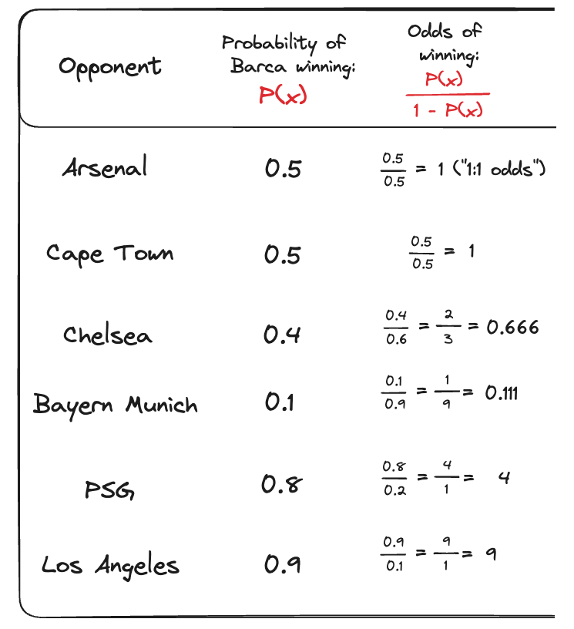

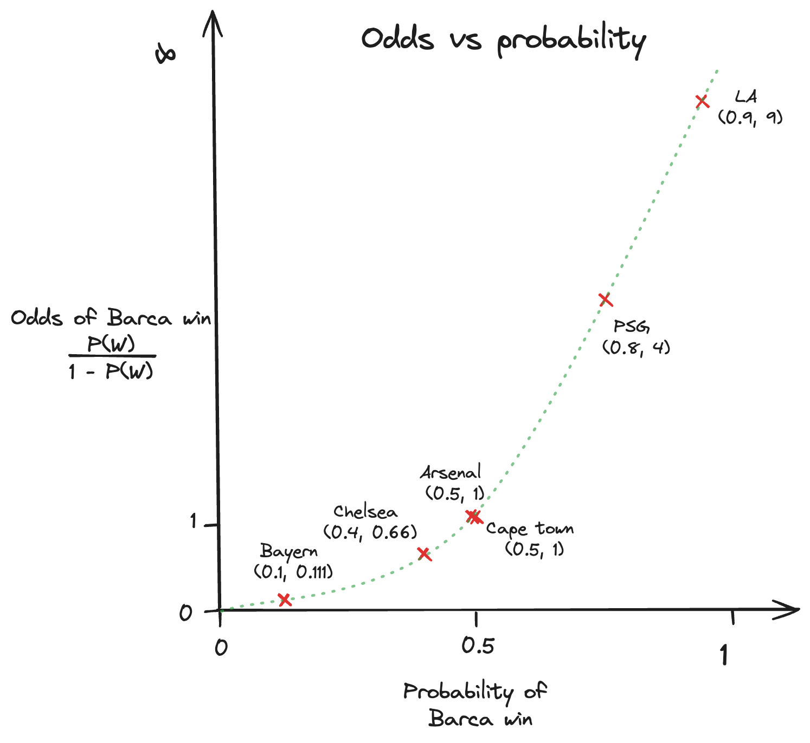

And the **log** of the odds 🤔

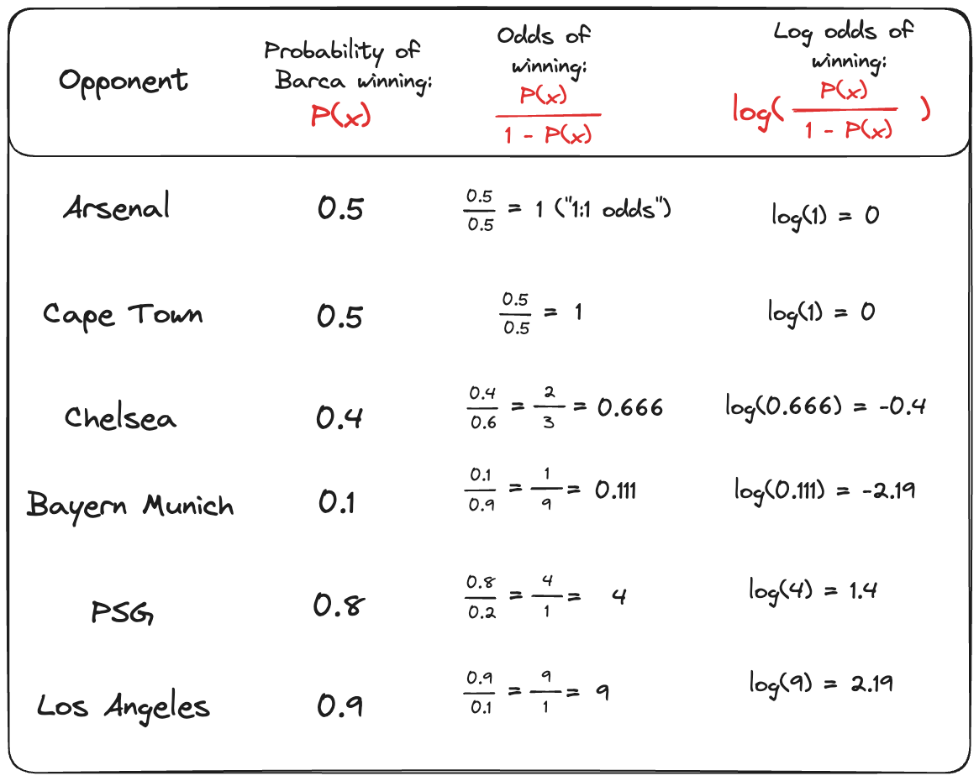

👉The Logit function maps a probability

p

∈

[

0

,

1

]

to its log-odds

∈

[

−

∞

,

+

∞

]

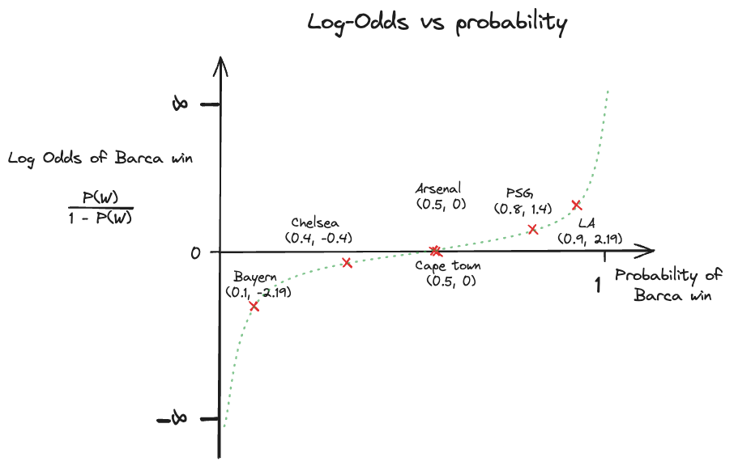

#### **The games are played and the results are in!**

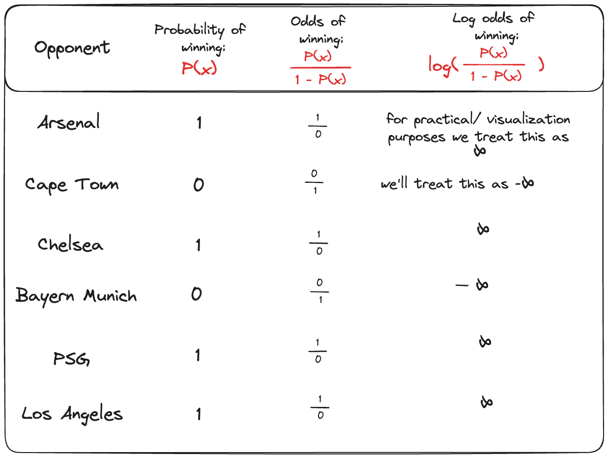

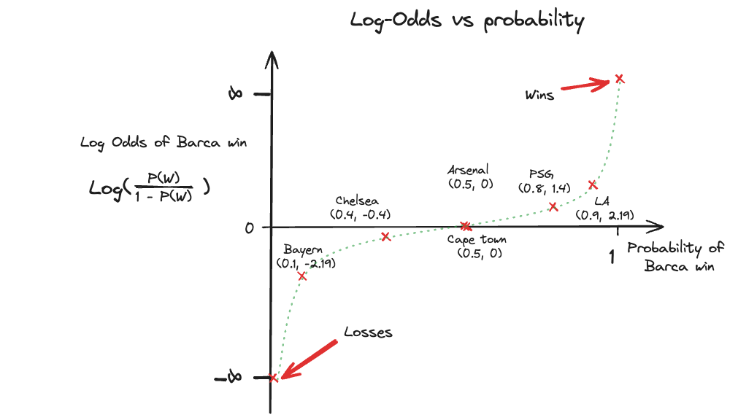

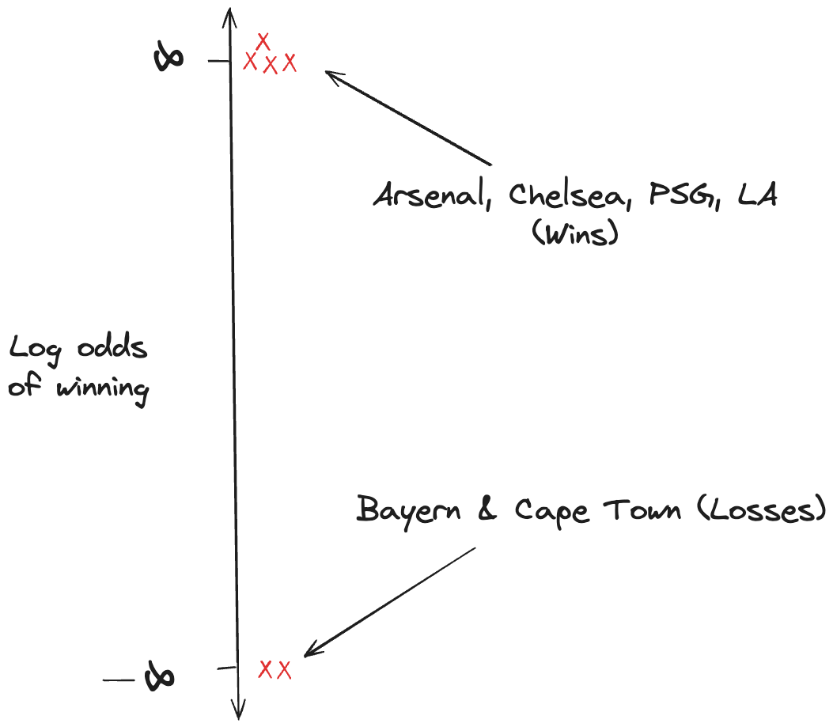

#### **We hear news that another game will be played!**

We've lost some money and we want to build a model so we can predict what the outcome will be. But **can we**?

**Not really!** All we know is that Barca has played 6 games: they won 4 and lost 2.

We have no explanatory variables (

X

) to determine our outcome (

y

)

So the naive method we have to work with is that Barca win 4/6 times so

P

(

Barcelona winning

)

=

0.666

#### **A friend comes to us with some insider knowledge 👀**

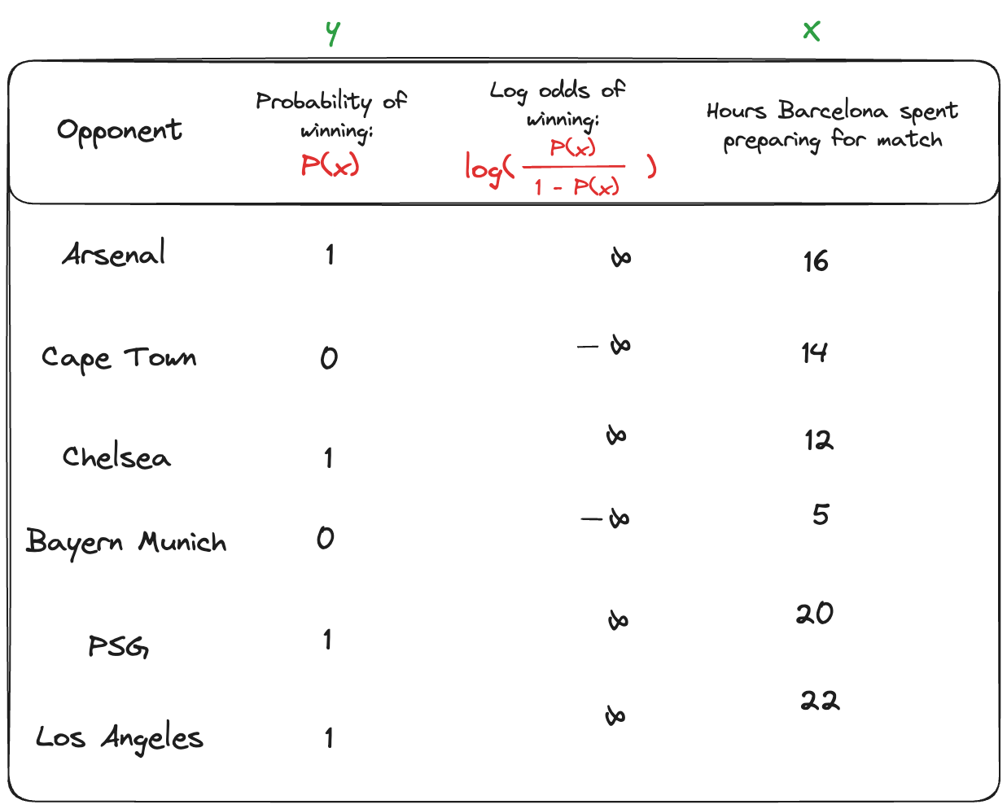

### **Let's visualize things again**

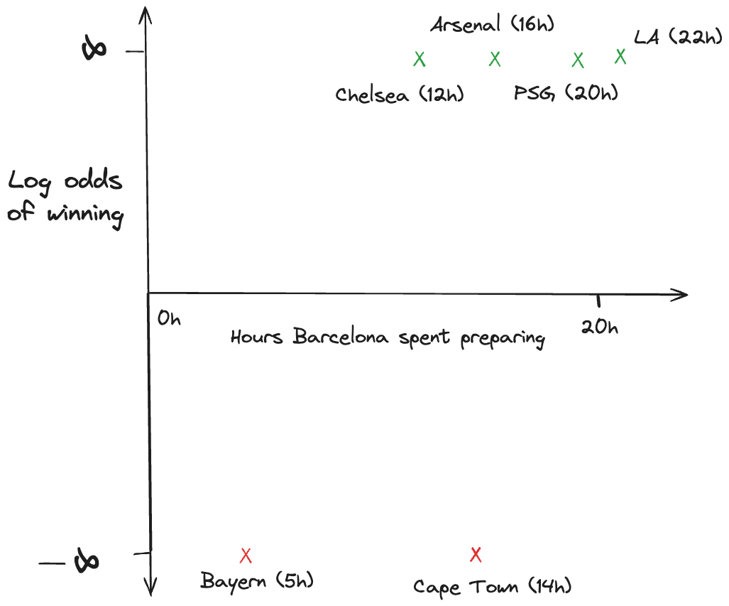

### **Create a first try at "best fit" line**

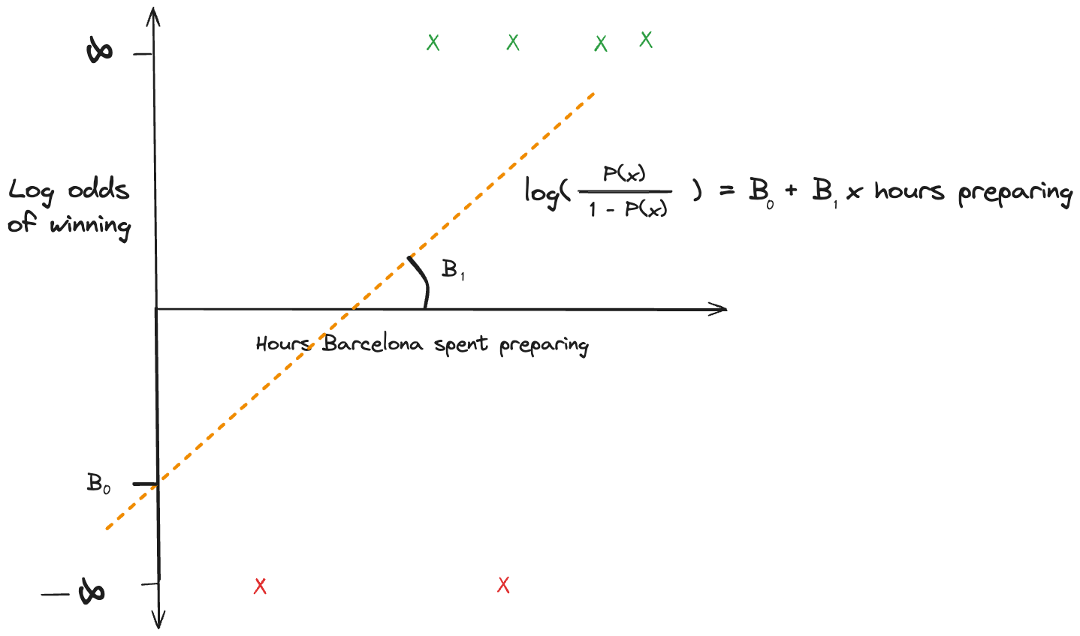

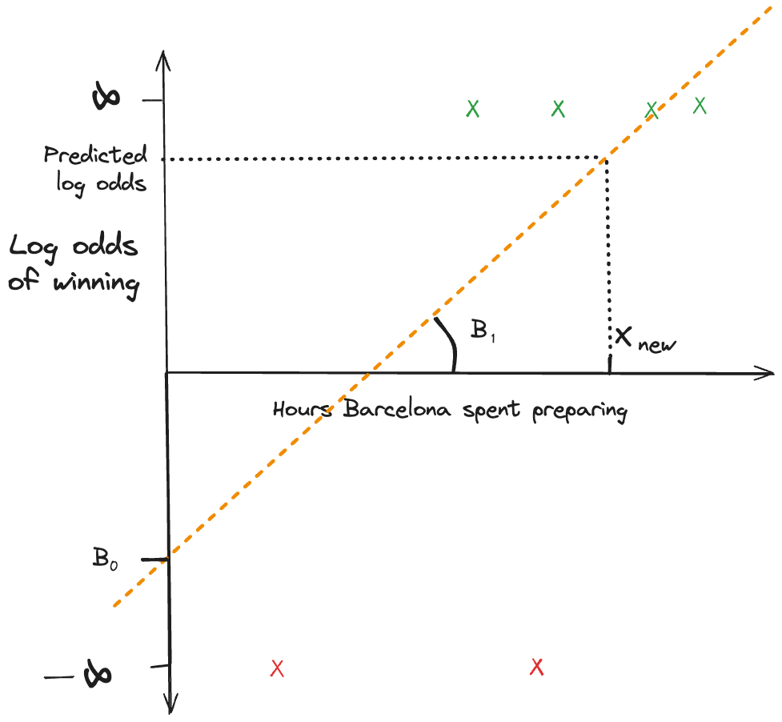



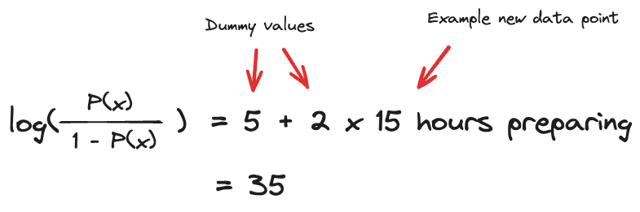

#### **But I thought we were interested in probabilities! What happened to that nice S-shaped curve? 🤔**

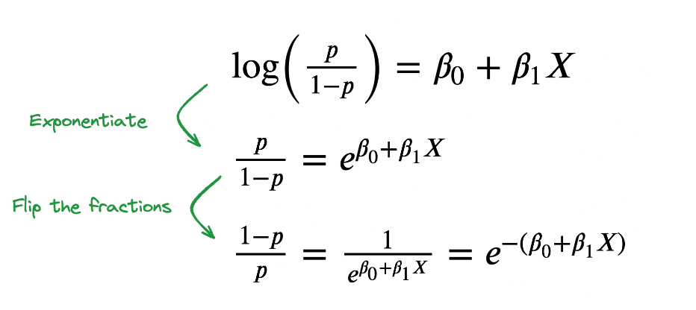

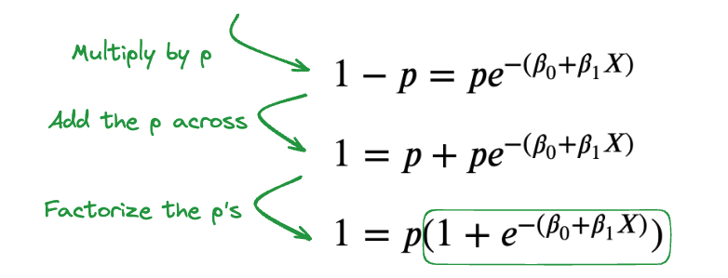



### **Let's take a look**

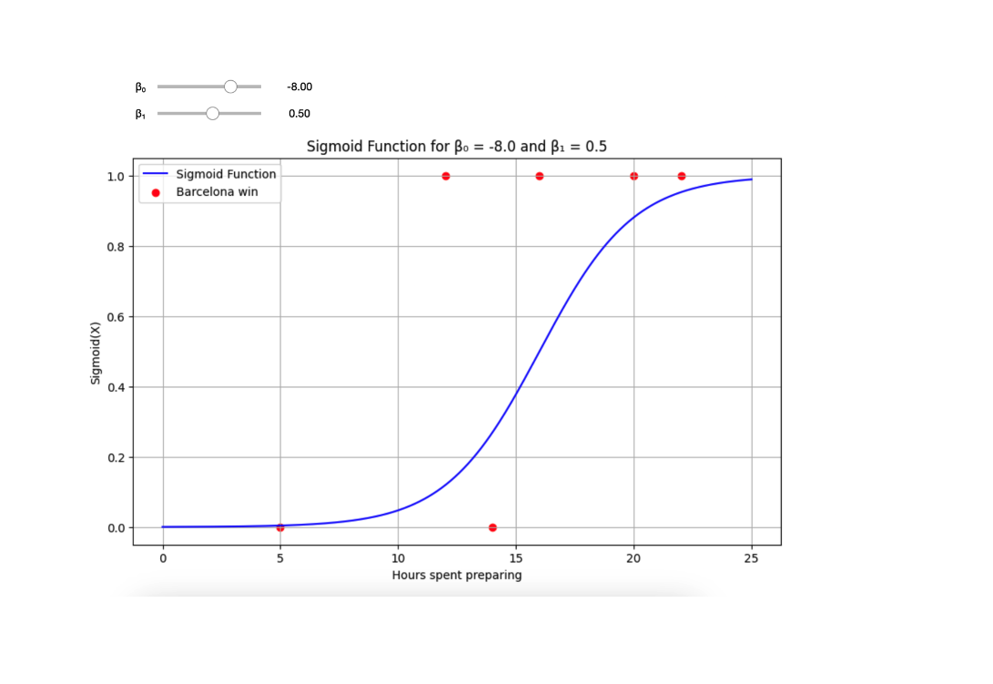

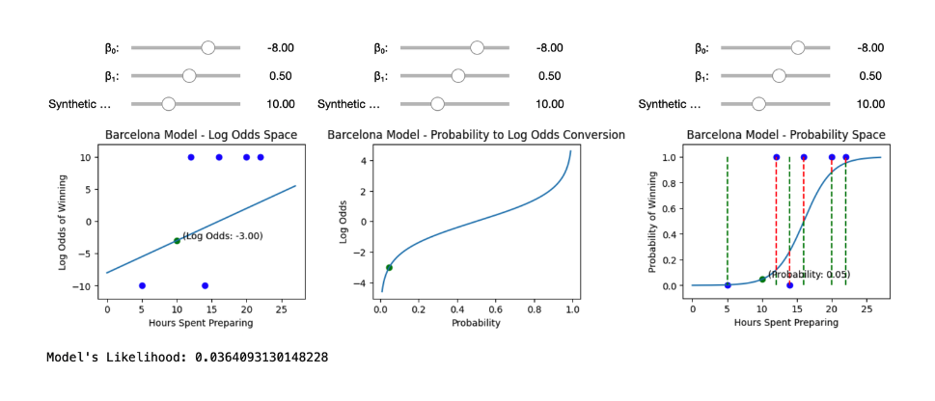

#### **But how should we decide on the best coefficients?**

Our results vector is represented as:

y

=

[

1

,

0

,

1

,

0

,

1

,

1

]

We **want** our model's predictions to be close to this:



How do we tweak our betas to optimize for this?

* Minimize some distance in the log odds space? ❌
* Minimize MSE in the probability space? ❌
* Minimize MAE in the probability space? ❌

👀 Consider rather the following **product**:

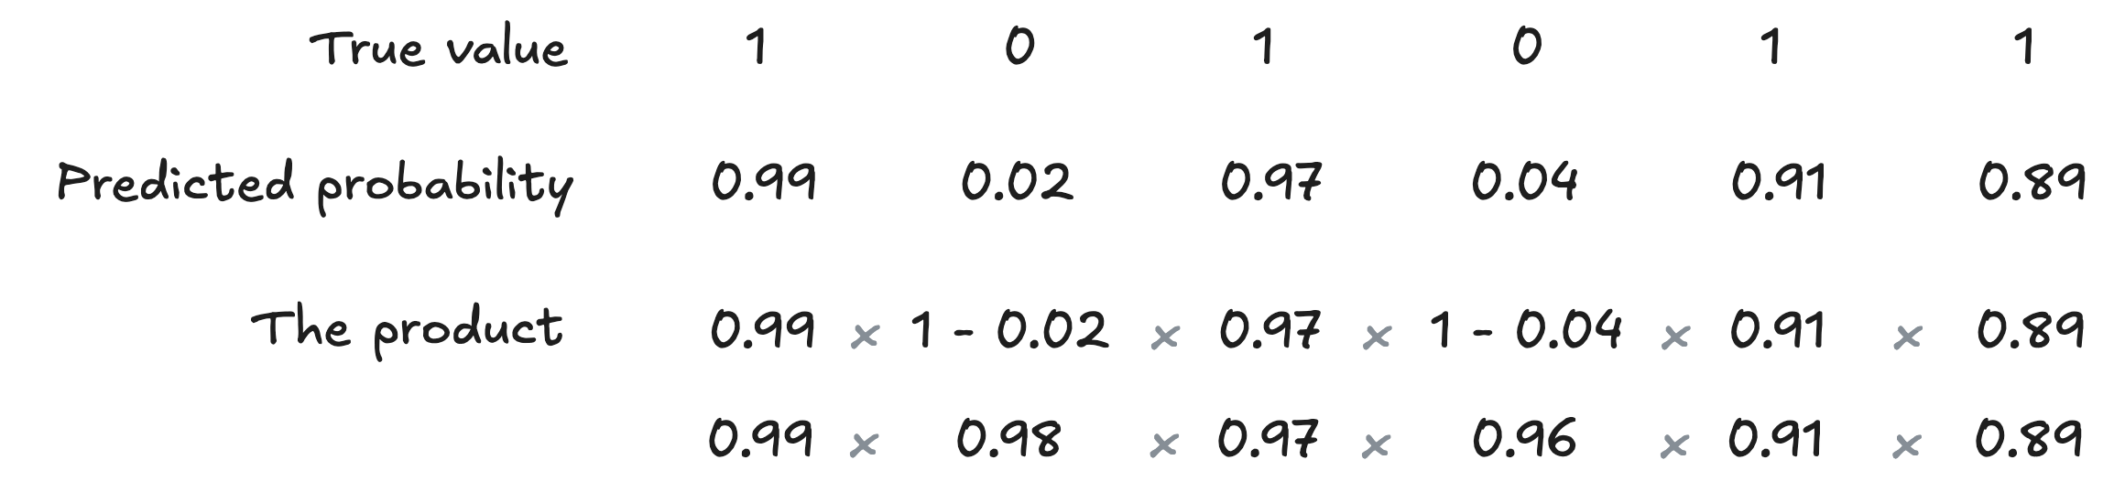

* It is always between 0 and 1
* The closer to 1, the better 🎉

This is *precisely* the **combined probability of observing all the independent**

y

i

**outcomes, if they were drawn from Bernoulli distributions of parameters**

p

=

^

y

i

([👉 A visual explanation](https://github.com/lewagon/data-images/blob/master/decision-science/likelihood-logisitc.png?raw=true))

✅ This is called the **Likelihood**

L

(

β

)

=

0.99

×

(

1

−

0.02

)

×

0.97

×

(

1

−

0.04

)

×

0.91

×

0.89

Likelihood of observing

y

, given the predicted probabilities

^

y

"We want to choose 𝛽 so as to make the data as probable as possible"

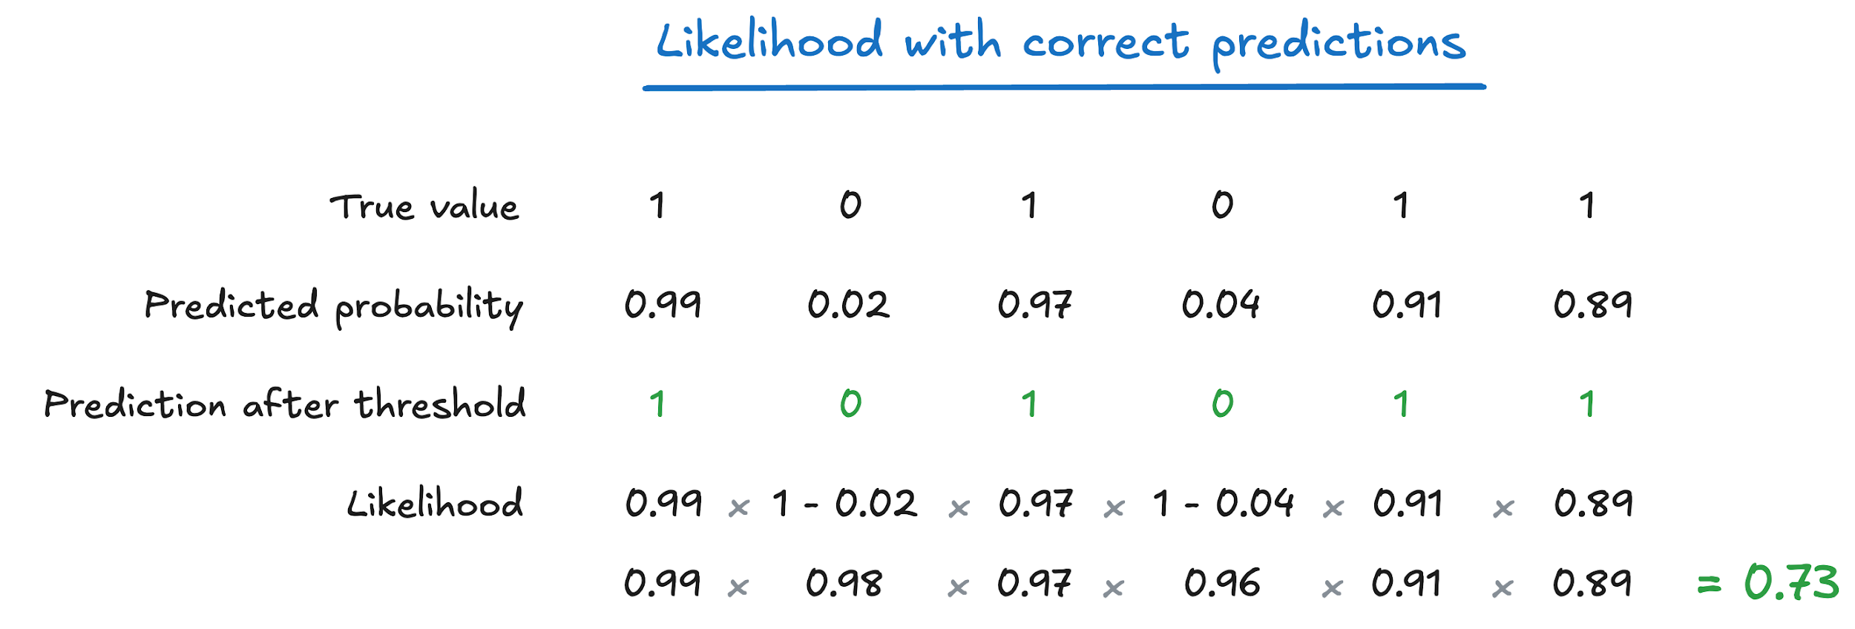

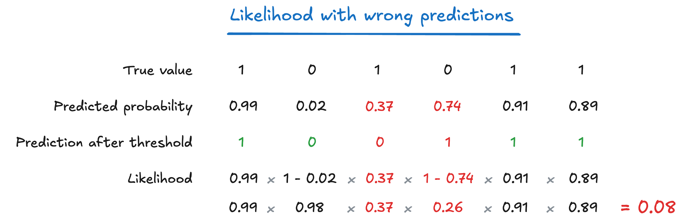

**Advanced:** Under the hood, our models actually try to maximize log-likelihood

* Still gives the same optimum point as maximizing likelihood
* But is guaranteed to be convex
* More numerically stable

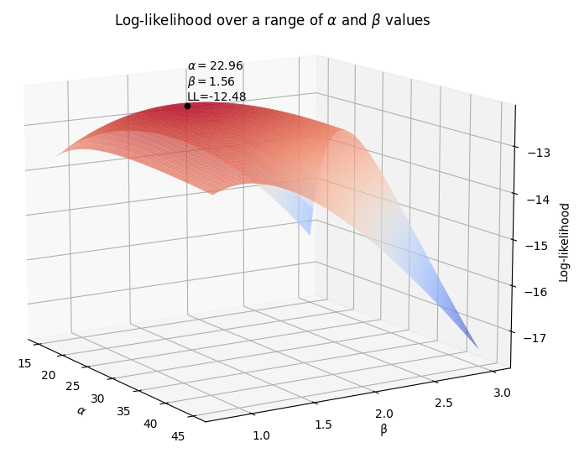

👀 You'll see more visualizations like this in ML weeks!

📖 [Further reading on using log loss and why we use it here!](https://medium.com/towards-data-science/why-not-mse-as-a-loss-function-for-logistic-regression-589816b5e03c)

🚀 By maximizing **Likelihood**, a Logistic Regression is really just trying to predict **probabilities**



👉 On average, for **100** observations

x

1

,

.

.

.

,

x

100

that are predicted to have

^

y

i

close to **0.95**, e.g. in [0.94-0.96]

* ≈
* **95** of them will turn up to be true
* y
* i
* =
* 1
* Your model will classify them correctly
* ≈
* 95% of the time

☝️ We say that Logistic Classifiers are **calibrated** classifiers! (very important)

## **3. Interpreting Logistic Regression**

### **3.1 Reading coefficients**

🥋 Let's take an example!

🛳 The Titanic dataset contains survival outcomes (0/1) for ~900 passengers of the Titanic:

titanic = sns.load_dataset("titanic")

titanic.head(3)

|  | **survived** | **pclass** | **sex** | **age** | **sibsp** | **parch** | **fare** | **embarked** | **class** | **who** | **adult_male** | **deck** | **embark_town** | **alive** | **alone** |
| --- | --- | --- | --- | --- | --- | --- | --- | --- | --- | --- | --- | --- | --- | --- | --- |
| **0** | 0 | 3 | male | 22.0 | 1 | 0 | 7.2500 | S | Third | man | True | NaN | Southampton | no | False |
| **1** | 1 | 1 | female | 38.0 | 1 | 0 | 71.2833 | C | First | woman | False | C | Cherbourg | yes | False |
| **2** | 1 | 3 | female | 26.0 | 0 | 0 | 7.9250 | S | Third | woman | False | NaN | Southampton | yes | True |

#### **Without any feature**

👉 To start, let's run the following logistic regression:

S

u

r

v

i

v

e

d

i

=

β

0

model1 = smf.logit(formula='survived ~ 1', data=titanic).fit();

model1.params

Optimization terminated successfully.

Current function value: 0.665912

Iterations 4

Intercept -0.473288

dtype: float64

The log-odd of surviving titanic is -0.47

❓What does the intercept correspond to ❓

log_odd =

l

o

g

(

p

1

−

p

)

=

β

0

= -0.47

⇔

odds =

p

1

−

p

=

e

x

p

(

−

0.47

)

= 0.62

⇔

Probability

p

=

0.62

1

+

0.62

= 38%

Chance of surviving = 38%

🕵🏻 Let's double check this:

cross_tab = pd.DataFrame({

'count': titanic['survived'].value_counts(),

'percentage': titanic['survived'].value_counts(normalize=**True**)

})

round(cross_tab,2)

|  | **count** | **percentage** |
| --- | --- | --- |
| **0** | 549 | 0.62 |
| **1** | 342 | 0.38 |

#### **With 1 continuous feature**

🥋 Let's add another term to the model:

S

u

r

v

i

v

e

d

=

β

0

+

β

f

a

r

e

F

a

r

e

F

a

r

e

= Fare that passenger paid (in dollars, continuous variable)

model3 = smf.logit(formula='survived ~ fare', data=titanic).fit()

model3.params

Optimization terminated successfully.

Current function value: 0.627143

Iterations 6

Intercept -0.941330

fare 0.015197

dtype: float64

##### ***How to interpret the fare coefficient?***

Increasing fare by 1 dollar increases the log odds of surviving by 0.015

Taking the exponential:

exp

(

0.015

)

=

1.01

For each additional dollar spent on fare, the odds of surviving increase by 1%

model3 = smf.logit(formula='survived ~ fare', data=titanic).fit()

model3.params

Optimization terminated successfully.

Current function value: 0.627143

Iterations 6

Intercept -0.941330

fare 0.015197

dtype: float64

##### ***How to interpret the intercept?***

The log-odds of surviving for a passenger who paid nothing is -0.94

#### **With 1 categorical feature**

🥋 Let's add one term to the model:

S

u

r

v

i

v

e

d

=

β

0

+

β

c

l

a

s

s

p

c

l

a

s

s

p

c

l

a

s

s

- Corresponds to the passenger class as a categorical variable (1,2 or 3)

model2 = smf.logit(formula='survived ~ C(pclass)', data=titanic).fit()

model2.params

Optimization terminated successfully.

Current function value: 0.607805

Iterations 5

Intercept 0.530628

C(pclass)[T.2] -0.639431

C(pclass)[T.3] -1.670399

dtype: float64

0.53 is the log-odds of surviving for a passenger who was in the first class

-0.63 is the **decrease** in the log-odds of survival for a 2nd class passenger, **relatively** to a 1st class passenger.

log

(

o

d

d

s

2

)

−

log

(

o

d

d

s

1

)

=

−

0.63

⇔

log

(

o

d

d

2

o

d

d

1

)

=

−

0.63

⇔

o

d

d

s

1

o

d

d

s

2

=

exp

(

0.63

)

=

1.87

The odds of surviving in 2nd class is **divided** by 1.87 compared to the 1st class!

#### **With multiple features**

model2 = smf.logit(formula='survived ~ fare + C(sex) + age', data=titanic).fit()

model2.params

Optimization terminated successfully.

Current function value: 0.501450

Iterations 6

Intercept 0.934841

C(sex)[T.male] -2.347599

fare 0.012773

age -0.010570

dtype: float64

Holding *fare* and *age* constant, being a male in Titanic reduces your log-odds of survival by 2.34 compared to a female passenger

## **4. Evaluate performance**

model4 = smf.logit(formula='survived ~ fare + C(sex) + age', data=titanic).fit()

model4.summary()

Optimization terminated successfully.

Current function value: 0.501450

Iterations 6

| **Dep. Variable:** | survived | **No. Observations:** | 714 |
| --- | --- | --- | --- |
| **Model:** | Logit | **Df Residuals:** | 710 |
| **Method:** | MLE | **Df Model:** | 3 |
| **Date:** | Tue, 16 Nov 2021 | **Pseudo R-squ.:** | 0.2576 |
| **Time:** | 04:41:04 | **Log-Likelihood:** | -358.04 |
| **converged:** | True | **LL-Null:** | -482.26 |
| **Covariance Type:** | nonrobust | **LLR p-value:** | 1.419e-53 |

|  | **coef** | **std err** | **z** | **P>|z|** | **[0.025** | **0.975]** |
| --- | --- | --- | --- | --- | --- | --- |
| **Intercept** | 0.9348 | 0.239 | 3.910 | 0.000 | 0.466 | 1.403 |
| **C(sex)[T.male]** | -2.3476 | 0.190 | -12.359 | 0.000 | -2.720 | -1.975 |
| **fare** | 0.0128 | 0.003 | 4.738 | 0.000 | 0.007 | 0.018 |
| **age** | -0.0106 | 0.006 | -1.627 | 0.104 | -0.023 | 0.002 |

🤓 **Fully annotated** model summary [cheatsheet](https://wagon-public-datasets.s3.amazonaws.com/data-science-images/lectures/decision-science/LogReg/log_reg_cheatsheet.png)

### **4.1 Inference**

* **p-values**: work similarly to p-values in Linear Regression
* **z-score** is used instead of t-score because in a Bernoulli process, the variance is known and doesn't need to be estimated:
* σ
* 2
* =
* p
* (
* 1
* −
* p
* )

#### **Less stringent conditions compared to Linear OLS regression**

✅ Random sampling

✅ Independent sampling (sample with replacement, or n < 10% global pop.)

❌ NOT NEEDED: Residuals normally distributed and of equal variance

### **4.2 Goodness-of-fit (**

### R

### 2

### **or equivalent?)**

model4.summary()

| **Dep. Variable:** | survived | **No. Observations:** | 714 |
| --- | --- | --- | --- |
| **Model:** | Logit | **Df Residuals:** | 710 |
| **Method:** | MLE | **Df Model:** | 3 |
| **Date:** | Tue, 16 Nov 2021 | **Pseudo R-squ.:** | 0.2576 |
| **Time:** | 04:41:10 | **Log-Likelihood:** | -358.04 |
| **converged:** | True | **LL-Null:** | -482.26 |
| **Covariance Type:** | nonrobust | **LLR p-value:** | 1.419e-53 |

|  | **coef** | **std err** | **z** | **P>|z|** | **[0.025** | **0.975]** |
| --- | --- | --- | --- | --- | --- | --- |
| **Intercept** | 0.9348 | 0.239 | 3.910 | 0.000 | 0.466 | 1.403 |
| **C(sex)[T.male]** | -2.3476 | 0.190 | -12.359 | 0.000 | -2.720 | -1.975 |
| **fare** | 0.0128 | 0.003 | 4.738 | 0.000 | 0.007 | 0.018 |
| **age** | -0.0106 | 0.006 | -1.627 | 0.104 | -0.023 | 0.002 |

**log-likelihood (LL)**

* log(likelihood) =
* l
* o
* g
* (
* 0.99
* ×
* (
* 1
* −
* 0.02
* )
* ×
* .
* .
* .
* ×
* 0.89
* )
* ∈
* [
* −
* ∞
* ,
* 0
* ]
* the closer to 0 the better!
* **plays a similar role to "Sum of Squared Residuals" in Linear Regression**

R-squared (linear regression)

=

1

−

S

S

resid

S

S

mean

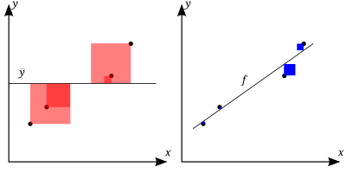

**Pseudo R-squared** for Logistic regression

1

−

L

L

(

p

r

e

d

i

c

t

)

L

L

(

mean

)

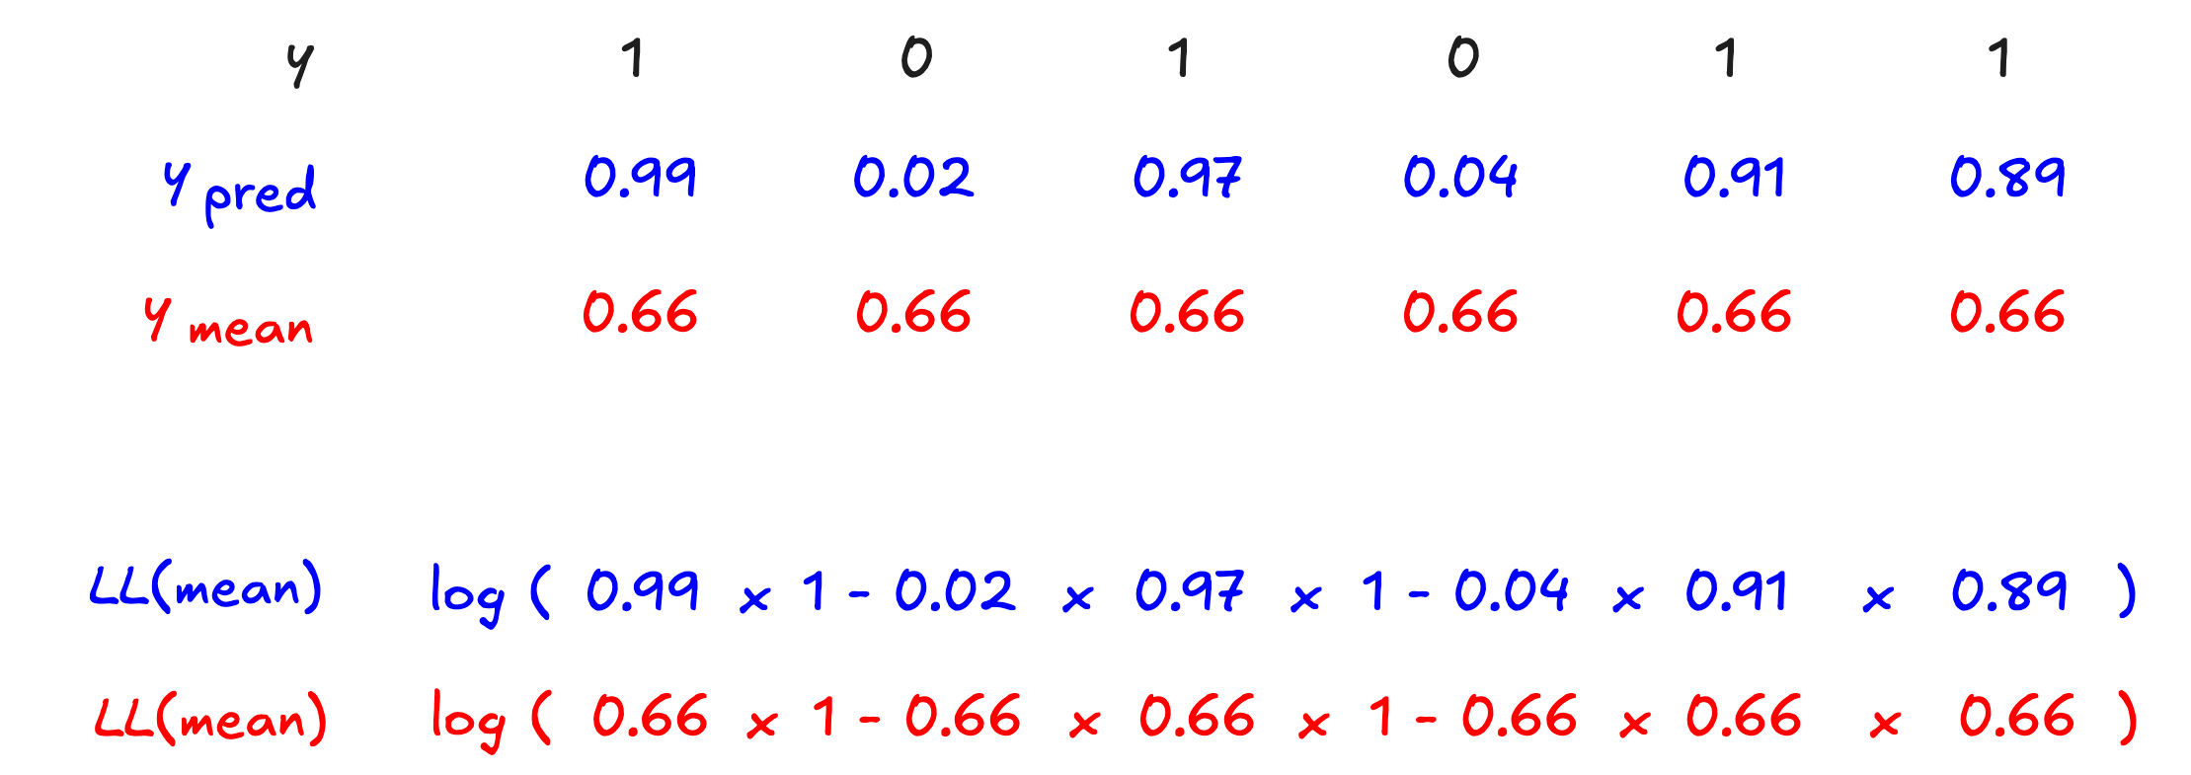

**Pseudo R-squared**

✅ in [0-1]  
✅ useful to compare models predicting the same problem from same data X

❌ is not as descriptive as the R-squared, once the classification threshold is applied

* e.g. predicted probabilities of 0.49 vs. 0.51 are extremely close...
* ... but yield opposite classification predictions!

📅 We will discover the most important **Performance Metrics for classification** during the Machine Learning module

(accuracy, precision, recall, f1_score, ...)

## **5. Multicollinearity issues in Linear/Logistic Regression**

Imagine that a feature

X

k

is a linear combination of other features (e.g.

X

8

=

X

1

+

X

3

)

🤔 How can you "Vary

X

k

**while holding all other features constant**" ❓❗️ You can't.

### **4.1 Strict multicollinearity**

Which feature matrix is best suited for regression?

A

array([[1., 0., 1.],

[0., 1., 1.],

[0., 0., 0.]])

B

array([[1., 0., 0.],

[0., 1., 0.],

[0., 0., 1.]])

print(' rank(A):', np.linalg.matrix_rank(A), '**\n**',

'rank(B):', np.linalg.matrix_rank(B))

rank(A): 2

rank(B): 3

☝️ The rank of a matrix is the dimension of the vector space generated by its columns

⚠️ Feature Matrix needs to be "full rank" to run any Linear/Logistic model!

❗️

C

3

=

C

1

+

C

2

: the third column/feature is a linear combination of the first two columns so would need to remove it to perform a correct Linear/Logistic Model

#### **Example**

mpg = sns.load_dataset('mpg').dropna().drop(columns=['origin', 'name', 'displacement'])

mpg.corr().style.background_gradient(cmap='coolwarm')

|  | **mpg** | **cylinders** | **horsepower** | **weight** | **acceleration** | **model_year** |
| --- | --- | --- | --- | --- | --- | --- |
| **mpg** | 1.000000 | -0.777618 | -0.778427 | -0.832244 | 0.423329 | 0.580541 |
| **cylinders** | -0.777618 | 1.000000 | 0.842983 | 0.897527 | -0.504683 | -0.345647 |
| **horsepower** | -0.778427 | 0.842983 | 1.000000 | 0.864538 | -0.689196 | -0.416361 |
| **weight** | -0.832244 | 0.897527 | 0.864538 | 1.000000 | -0.416839 | -0.309120 |
| **acceleration** | 0.423329 | -0.504683 | -0.689196 | -0.416839 | 1.000000 | 0.290316 |
| **model_year** | 0.580541 | -0.345647 | -0.416361 | -0.309120 | 0.290316 | 1.000000 |

mpg['lin_comb'] = 10 * mpg['cylinders'] - 0.3 * mpg['horsepower']

mpg.head(3)

|  | **mpg** | **cylinders** | **horsepower** | **weight** | **acceleration** | **model_year** | **lin_comb** |
| --- | --- | --- | --- | --- | --- | --- | --- |
| **0** | 18.0 | 8 | 130.0 | 3504 | 12.0 | 70 | 41.0 |
| **1** | 15.0 | 8 | 165.0 | 3693 | 11.5 | 70 | 30.5 |
| **2** | 18.0 | 8 | 150.0 | 3436 | 11.0 | 70 | 35.0 |

*# Matrix is not full-rank!*

print(mpg.shape)

np.linalg.matrix_rank(mpg)

(392, 7)

6

smf.ols(formula='weight ~ cylinders + horsepower + lin_comb', data=mpg).fit().params

Intercept 528.876711

cylinders 3.375029

horsepower 16.840512

lin_comb 28.698140

dtype: float64

*# Now, change just a bit one single observation by 1% just on one feature*

mpg.loc[0,'horsepower'] = mpg.loc[0,'horsepower']*1.01

smf.ols(formula='weight ~ cylinders + horsepower + lin_comb', data=mpg).fit().params

Intercept 524.838981

cylinders 11398.211049

horsepower -325.000813

lin_comb -1110.583430

dtype: float64

*# Statsmodels gives us a clear WARNING [2]*

*# Summary table also reads 'Covariance Type: nonrobust'*

smf.ols(formula='weight ~ cylinders + horsepower + lin_comb', data=mpg).fit().summary()

| **Dep. Variable:** | weight | **R-squared:** | 0.846 |
| --- | --- | --- | --- |
| **Model:** | OLS | **Adj. R-squared:** | 0.845 |
| **Method:** | Least Squares | **F-statistic:** | 712.9 |
| **Date:** | Tue, 16 Nov 2021 | **Prob (F-statistic):** | 1.99e-157 |
| **Time:** | 04:41:18 | **Log-Likelihood:** | -2832.3 |
| **No. Observations:** | 392 | **AIC:** | 5673. |
| **Df Residuals:** | 388 | **BIC:** | 5689. |
| **Df Model:** | 3 |  |  |
| **Covariance Type:** | nonrobust |  |  |

|  | **coef** | **std err** | **t** | **P>|t|** | **[0.025** | **0.975]** |
| --- | --- | --- | --- | --- | --- | --- |
| **Intercept** | 524.8390 | 56.865 | 9.230 | 0.000 | 413.038 | 636.640 |
| **cylinders** | 1.14e+04 | 8616.113 | 1.323 | 0.187 | -5541.902 | 2.83e+04 |
| **horsepower** | -325.0008 | 258.480 | -1.257 | 0.209 | -833.198 | 183.196 |
| **lin_comb** | -1110.5834 | 861.454 | -1.289 | 0.198 | -2804.285 | 583.118 |

| **Omnibus:** | 12.222 | **Durbin-Watson:** | 1.199 |
| --- | --- | --- | --- |
| **Prob(Omnibus):** | 0.002 | **Jarque-Bera (JB):** | 24.236 |
| **Skew:** | 0.069 | **Prob(JB):** | 5.46e-06 |
| **Kurtosis:** | 4.210 | **Cond. No.** | 5.84e+04 |

Warnings:

[1] Standard Errors assume that the covariance matrix of the errors is correctly specified.

[2] The condition number is large, 5.84e+04. This might indicate that there are

strong multicollinearity or other numerical problems.

⚠️ partial coefficients of collinear features become **extremely sensitive to changes in the data**

⚠️ Can trust **neither** your partial coefficients **nor** their associated p-values

✅ No impact on R2  
✅ No impact on partial coefficients for non-collinear features

### **5.2 Strong (but not strict) multicollinearity is still a problem!**

mpg['lin_comb'] = mpg['lin_comb'] + 0.05 * np.random.rand(mpg.shape[0])

np.linalg.matrix_rank(mpg)

7

smf.ols(formula='weight ~ cylinders + horsepower + lin_comb', data=mpg).fit().params

Intercept 544.560499

cylinders 8645.424045

horsepower -242.419334

lin_comb -835.251174

dtype: float64

*# Again, change just a bit one single observation in the dataset and check the OLS results*

mpg.loc[0,'horsepower'] = mpg.loc[0,'horsepower']*0.8

smf.ols(formula='weight ~ cylinders + horsepower + lin_comb', data=mpg).fit().params

Intercept 524.231116

cylinders 5.429155

horsepower 16.782814

lin_comb 28.688715

dtype: float64

### **5.3 How to detect multicollinearity**

*# Correlation matrix is not sufficient to detect soft or event strict multicollinearity*

mpg.corr().style.background_gradient(cmap='coolwarm')

|  | **mpg** | **cylinders** | **horsepower** | **weight** | **acceleration** | **model_year** | **lin_comb** |
| --- | --- | --- | --- | --- | --- | --- | --- |
| **mpg** | 1.000000 | -0.777618 | -0.777708 | -0.832244 | 0.423329 | 0.580541 | -0.445217 |
| **cylinders** | -0.777618 | 1.000000 | 0.841000 | 0.897527 | -0.504683 | -0.345647 | 0.762619 |
| **horsepower** | -0.777708 | 0.841000 | 1.000000 | 0.863997 | -0.687454 | -0.413903 | 0.292037 |
| **weight** | -0.832244 | 0.897527 | 0.863997 | 1.000000 | -0.416839 | -0.309120 | 0.554680 |
| **acceleration** | 0.423329 | -0.504683 | -0.687454 | -0.416839 | 1.000000 | 0.290316 | -0.067723 |
| **model_year** | 0.580541 | -0.345647 | -0.413903 | -0.309120 | 0.290316 | 1.000000 | -0.113352 |
| **lin_comb** | -0.445217 | 0.762619 | 0.292037 | 0.554680 | -0.067723 | -0.113352 | 1.000000 |

❗️ Correlation matrix detects **bivariate** collinearity between 2 features only ❗️

#### **🚀 VIF: Variance Inflation Factor**

* A measure of the amount of multicollinearity per feature
* The higher, the more multicollinear, the less useful the feature with a high VIF...
* Computed by **regressing one feature as function of all others** features and measuring R-squared

V

I

F

(

X

k

)

=

1

1

−

R

2

k

❗️Warning ❗️

When you plan to use multiple features in a linear model, do not forget to scale your data...

mpg_scaled = mpg.copy()

**for** feature **in** mpg_scaled.columns:

mu = mpg[feature].mean()

sigma = mpg[feature].std()

mpg_scaled[feature] = mpg_scaled[feature].apply(**lambda** x: (x-mu)/sigma)

mpg_scaled

|  | **mpg** | **cylinders** | **horsepower** | **weight** | **acceleration** | **model_year** | **lin_comb** |
| --- | --- | --- | --- | --- | --- | --- | --- |
| **0** | -0.697747 | 1.482053 | 0.016488 | 0.619748 | -1.283618 | -1.623241 | 1.832112 |
| **1** | -1.082115 | 1.482053 | 1.575127 | 0.842258 | -1.464852 | -1.623241 | 0.740041 |
| **2** | -0.697747 | 1.482053 | 1.185207 | 0.539692 | -1.646086 | -1.623241 | 1.208893 |
| **3** | -0.953992 | 1.482053 | 1.185207 | 0.536160 | -1.283618 | -1.623241 | 1.210761 |
| **4** | -0.825870 | 1.482053 | 0.925261 | 0.554997 | -1.827320 | -1.623241 | 1.523028 |
| **...** | ... | ... | ... | ... | ... | ... | ... |
| **393** | 0.455359 | -0.862911 | -0.478450 | -0.220842 | 0.021267 | 1.634321 | -0.956249 |
| **394** | 2.633448 | -0.862911 | -1.362268 | -0.997859 | 3.283479 | 1.634321 | 0.104867 |
| **395** | 1.095974 | -0.862911 | -0.530439 | -0.803605 | -1.428605 | 1.634321 | -0.895028 |
| **396** | 0.583482 | -0.862911 | -0.660413 | -0.415097 | 1.108671 | 1.634321 | -0.738686 |
| **397** | 0.967851 | -0.862911 | -0.582429 | -0.303253 | 1.398646 | 1.634321 | -0.832209 |

392 rows × 7 columns

**from** **statsmodels.stats.outliers_influence** **import** variance_inflation_factor **as** vif

*# compute VIF factor for feature index 0*

vif(mpg_scaled.values, 0)

5.236622675084839

df = pd.DataFrame()

df["features"] = mpg_scaled.columns

df["vif_index"] = [vif(mpg_scaled.values, i) **for** i **in** range(mpg_scaled.shape[1])]

round(df.sort_values(by="vif_index", ascending = **False**),2)

|  | **features** | **vif_index** |
| --- | --- | --- |
| **1** | cylinders | 2091.85 |
| **2** | horsepower | 943.73 |
| **6** | lin_comb | 668.13 |
| **3** | weight | 11.25 |
| **0** | mpg | 5.24 |
| **4** | acceleration | 2.61 |
| **5** | model_year | 1.90 |

☝️ Consider VIF value

≥

10 as a potential cause for concern (rule of thumb)

## **Summary: Regression Cheat Sheet**

| **Check** | **Description** | **Diagnosis (OLS)** | **Diagnosis (Logit)** |
| --- | --- | --- | --- |
| Goodness-of-fit | How well does our  y  p  r  e  d  explain the true  y  ? | R-squared | pseudo R-squared |
| Statistical significance | Are regression coefficients trustworthy? | p-values and t-tests | p-values and z-tests |
| Inference conditions | Can we trust the p-values ? | Residual plots | Not needed |
| Multicollinearity | Minimal dependence between features | VIF analysis | VIF analysis |

## **Bibliography 📚**

* [StatsQuest - Logistic Regression](https://www.youtube.com/playlist?list=PLblh5JKOoLUKxzEP5HA2d-Li7IJkHfXSe) (1-h youtube, very good intuitive summary)

## **🚀 Your turn!**

🗓 Challenge 01

* Applying your skills in Logistic Regression

🔥 Challenge 02

* You have 1.5 days to answer the CEO's request based on all the analysis, notebooks, logics that you have been coding so far